***Data Analytics***

**Case Study: Risk Analysis of Space Shuttle, Multiple Linear Regression analysis.**

1. **Data Refinary**

* Descriptive analytics of data

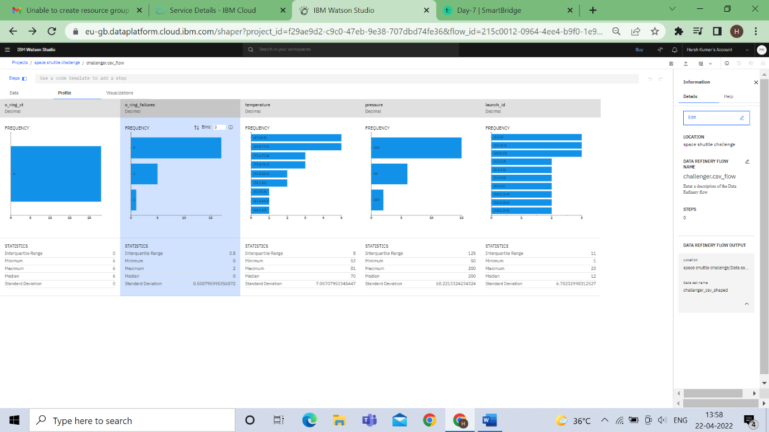

* Exploratory Analytics

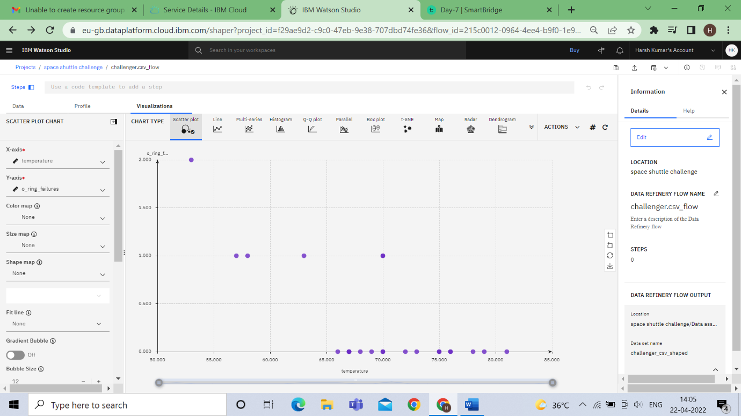

x-axis = temperature ,y-axis – o_ring_failures

* At Lower temperature failure are more,while at higher temperature failure are very less.

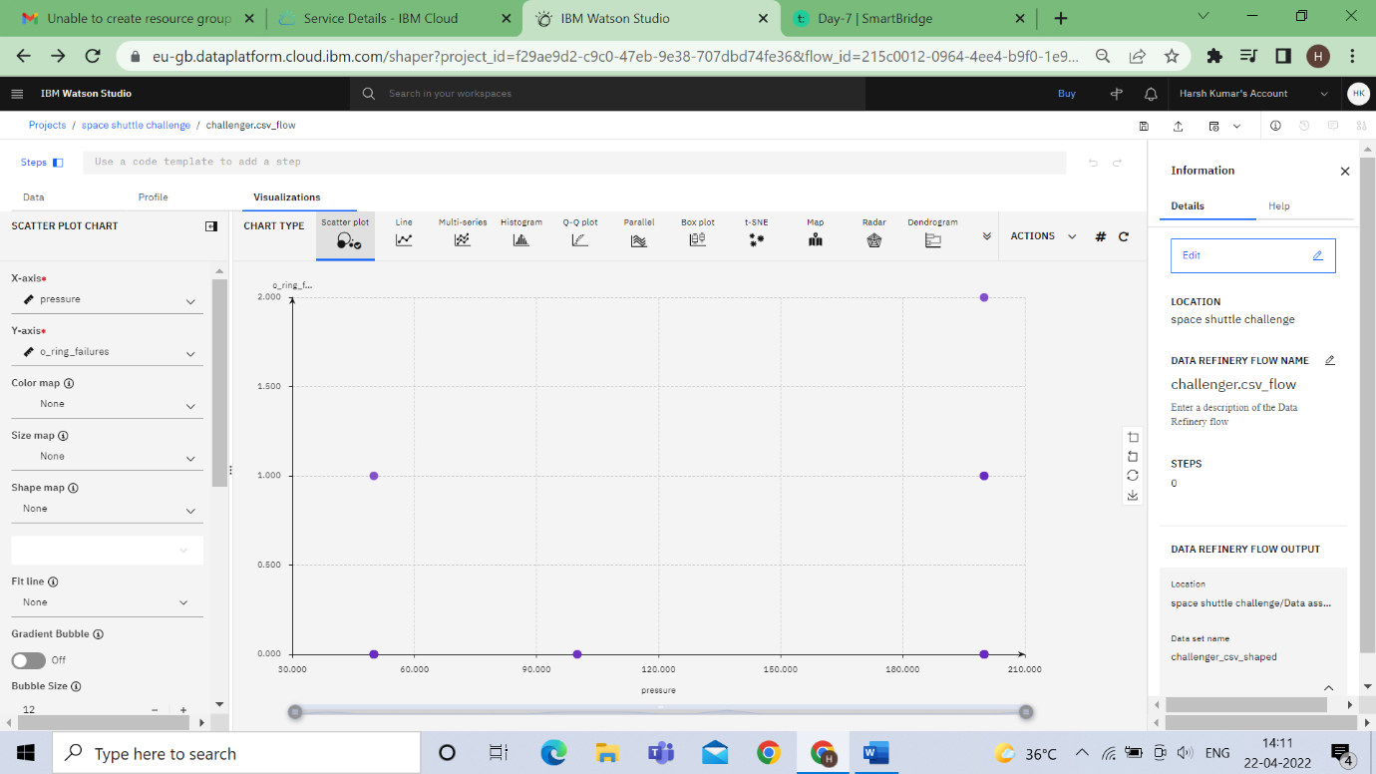

x-axis=Pressure ,y-axis= o_ring_failures

**2.SPSS Modeler**

* **Model**

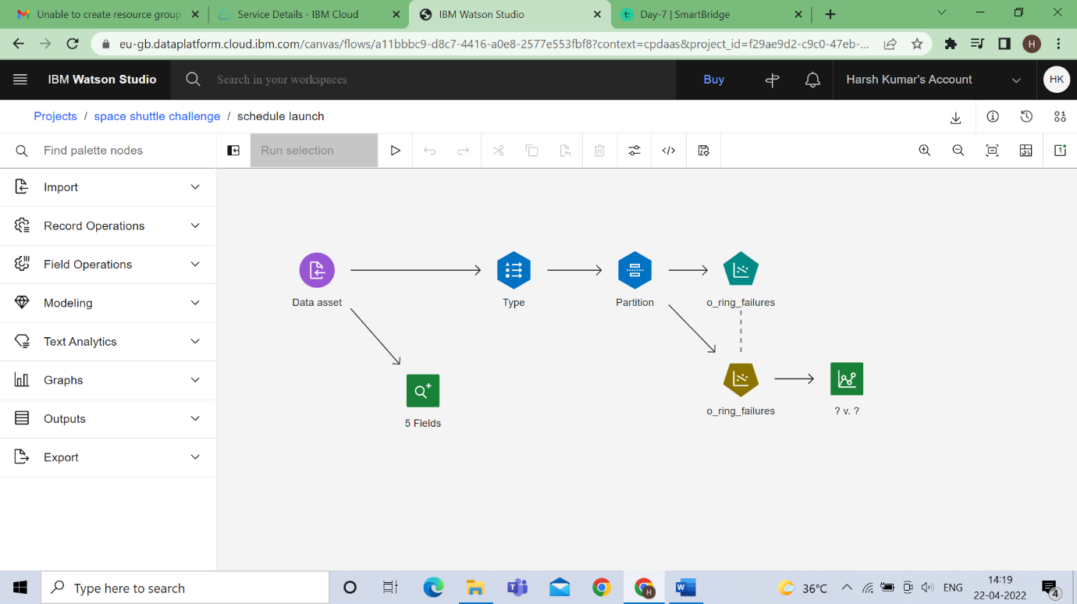

* **Type node**

**Temperature as Input**

**Pressure as input**

**O_ring_failure as Output or terget**

**Other as none**

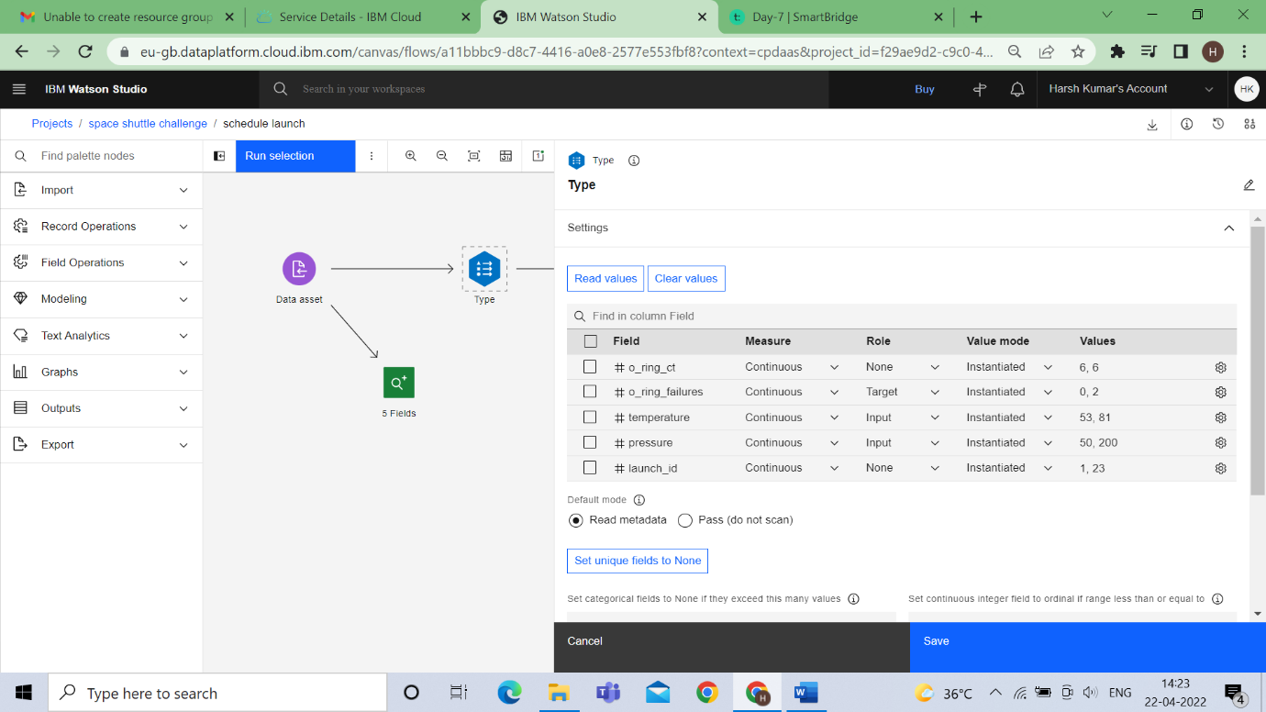

* **Partition node**

**Training – 70%**

**Testing – 30%**

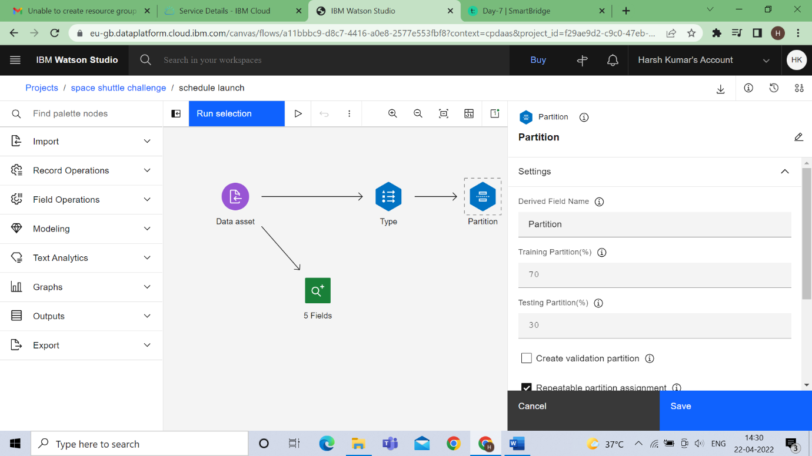

* **Model**



* **Output**
  + **View Model**

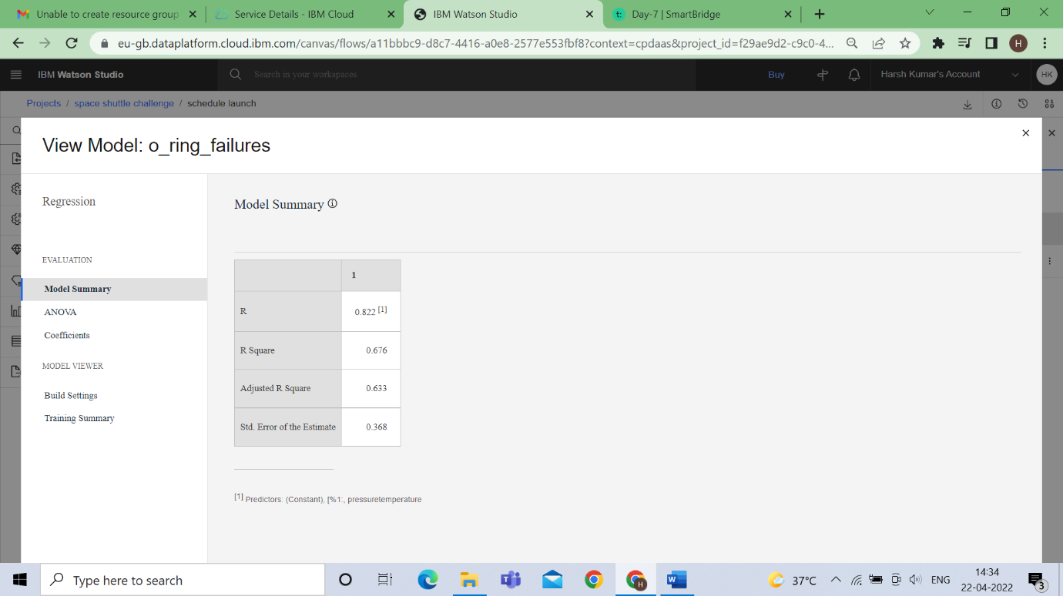

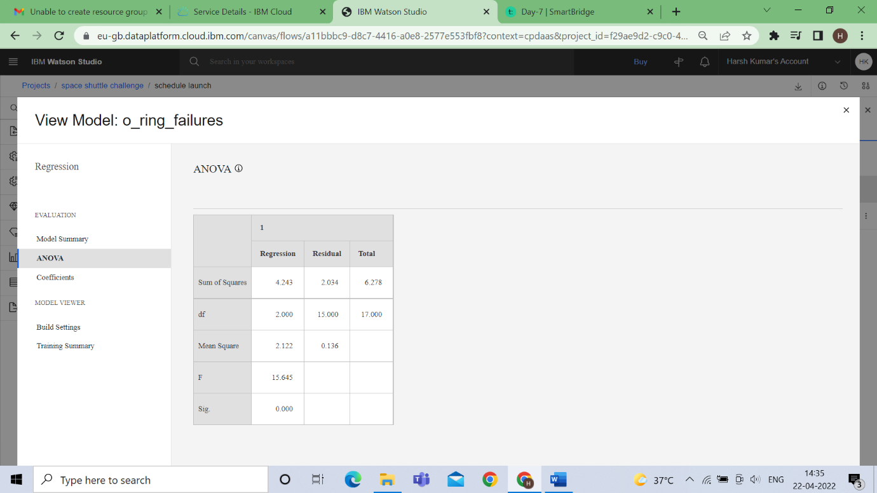

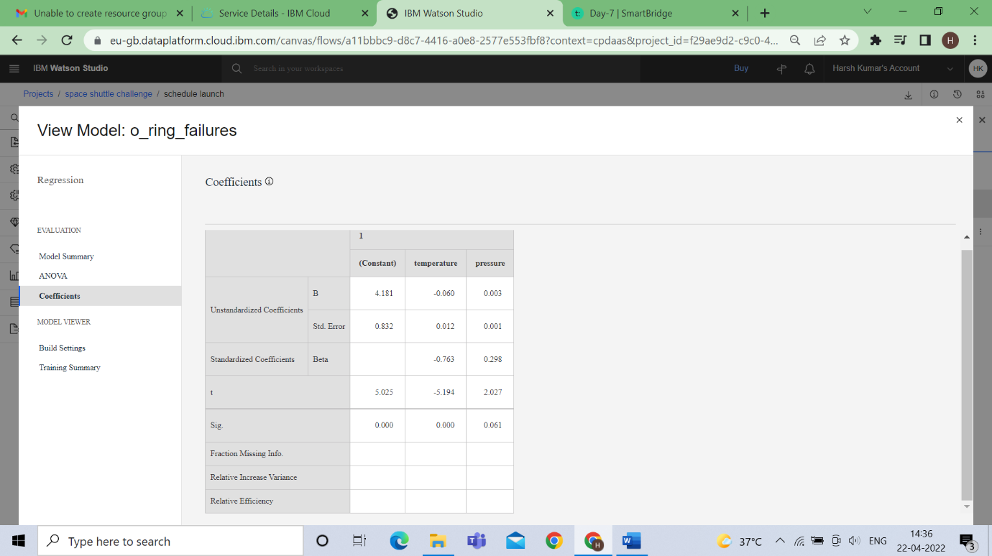

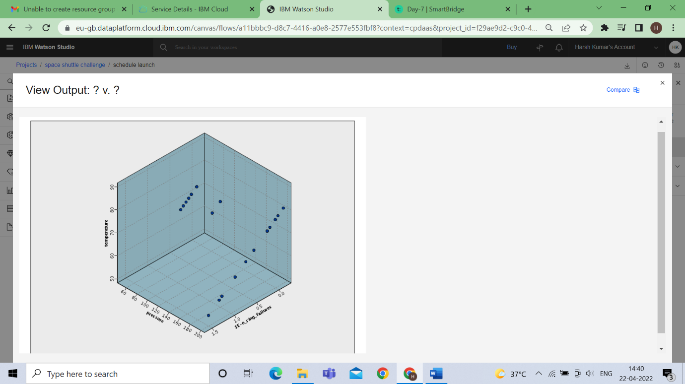

* + **Data Audit**

